Gap Analysis:
Professionalism in Nursing, March 2007
Work Sheet

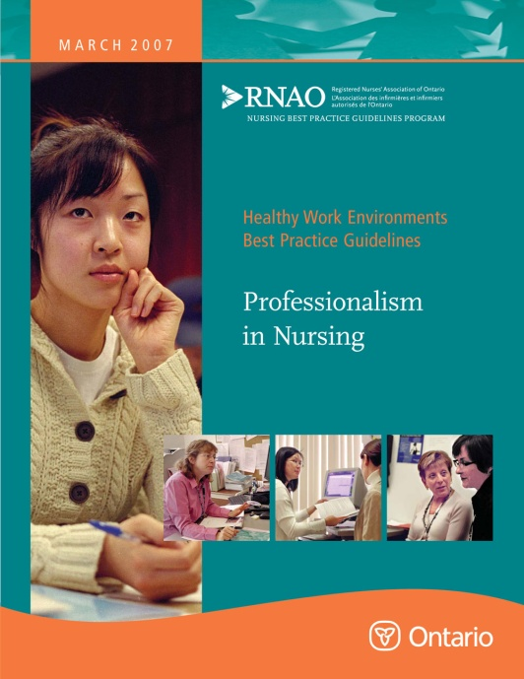

This guideline can be downloaded for free at:
http://rnao.ca/bpg/guidelines/professionalism-nursing

The RNAO Leading Change Toolkit ( 3rd edition)
Leading Change Toolkit™ | RNAO.ca

Date Completed:
Team Members participating in the Gap Analysis:

RNAO Healthy Work Environment Best Practice Guideline Recommendations | Met | Partially Met | Unmet | Notes  (Examples of what to include: is this a priority to our home, information on current practice, possible overlap with other programs or partners)
Knowledge 1. 0 Professionalism includes:
1.1 A body of knowledge that is theoretical, practical and clinical.
1.2 Being able to apply that knowledge.
1.3 Using theoretical and/or evidence-based rationale for practice.
1.4 Synthesizing information from a variety of sources.
1.5 Using information or evidence from nursing and other disciplines to inform practice.
1.6 Sharing or communicating knowledge with colleagues, clients, family and others to continually improve care and health outcomes.
Spirit of Inquiry 2. 0 Professionalism includes:
2.1 Being open-minded and having the desire to explore new knowledge.
2.2 Asking questions leading to the generation of knowledge and refinement of existing knowledge.
2.3 Striving to define patterns of responses from clients, stakeholders and their context.
2.4 Being committed to life-long learning.
Accountability 3. 0 Professionalism includes:
3.1 Understanding the meaning of self-regulation and its implications for practice.
3.2 Using legislation, standards of practice and a code of ethics to clarify one's scope of practice.
3.3 Being committed to work with clients and families to achieve desired outcomes.
3.4 Being actively engaged in advancing the quality of care.
3.5 Recognizing personal capabilities, knowledge base and areas for development.
Autonomy 4. 0 Professionalism includes:
4.1 Working independently and exercising decision-making within one's appropriate scope of practice.
4.2 Recognizing relational autonomy and the effects of the context and relationships on this autonomy.
4.3 Becoming aware of barriers and constraints that may interfere with one's autonomy and seeking ways to remedy the situation.
Advocacy 5. 0 Professionalism includes:
5.1 Understanding the client's perspective.
5.2 Assisting the client with their learning needs.
5.3 Being involved in professional practice initiatives and activities to enhance health care.
5.4 Being knowledgeable about policies that impact on delivery of health care.
Innovation and Visionary 6. 0 Professionalism includes:
6.1 Fostering a culture of innovation to enhance client/family outcomes.
6.2 Showing initiative for new ideas and being involved through taking action.
6.3 Influencing the future of nursing, delivery of health care and the health care system.
Collegiality and Collaboration 7. 0 Professionalism includes:
7.1 Developing collaborative partnerships within a professional context.
7.2 Acting as a mentor to nurses, nursing students and colleagues to enhance and support professional growth.
7.3 Acknowledging and recognizing interdependence between care providers.
Ethics and Values 8. 0 Professionalism includes:
8.1 Knowledgeable about ethical values, concepts and decision-making.
8.2 Being able to identify ethical concerns, issues and dilemmas.
8.3 Applying knowledge of nursing ethics to make decisions and to act on decisions.
8.4 Being able to collect and use information from various sources for ethical decision-making.
8.5 Collaborating with colleagues to develop and maintain a practice environment that supports nurses and respects their ethical and professional responsibilities.
8.6 Engaging in critical thinking about ethical issues in clinical and professional practice.

